House-Price- Prediction Using Machine Learning

House-Price- Prediction Using Machine Learning

A PROJECT REPORT

Submitted by

GUNASEKARAN M (812921104008)

LOGESWARAN O (812921104015)

THIRISHA E (812921104047)

THULASI P (812921104048)

BACHELOR OF ENGINEERING
In
COMPUTER SCIENCE AND ENGINEERING

Abstract
Predicting house prices is a crucial task in the real estate industry, offering valuable insights for buyers, sellers, and investors. Machine learning techniques have become a powerful tool for this purpose. This abstract provides an overview of a typical approach to house price prediction using machine learning.
The process begins with data collection, where historical housing prices and relevant property features are gathered. Data preprocessing follows, involving cleaning, encoding, and normalization. Feature selection and engineering help in improving the model's accuracy. The dataset is then divided into training and testing sets, and an appropriate regression algorithm is selected for model training.

Keywords:-

Python , Computer Vision , Neural Networks , Deep Learning , Image , Price Detection , House-Price-Prediction

TABLE OF CONTENT

CHAPTER NO | TITLE
 | Abstract
1 | Introduction
 | Data Processing, Data Collection, Data Cleaning
 | Feature Selection and Engineering, Data Transformation
 | Data Splitting, Data Visualization, Data Quality Check
 | Save Processed Data
2 | Flow chart
3 | PROGRAM
4 | OUTPUT
5 | Conclusion

Abstract :
Predicting house prices is a crucial task in the real estate industry, offering valuable insights for buyers, sellers, and investors. Machine learning techniques have become a powerful tool for this purpose. This abstract provides an overview of a typical approach to house price prediction using machine learning.

The process begins with data collection, where historical housing prices and relevant property features are gathered. Data preprocessing follows, involving cleaning, encoding, and normalization. Feature selection and engineering help in improving the model's accuracy. The dataset is then divided into training and testing sets, and an appropriate regression algorithm is selected for model training.

Evaluation metrics such as Mean Absolute Error (MAE), Mean Squared Error (MSE), and Root Mean Squared Error (RMSE) are employed to assess the model's performance. Hyperparameter tuning is conducted to optimize the model, and once satisfactory results are achieved, the model is deployed in a production environment.

Continual monitoring and maintenance are crucial, as house prices can change over time. Ethical considerations and compliance with regulations, if applicable, are essential throughout the process.This abstract highlights the key steps and considerations involved in house price prediction using machine learning, emphasizing the significance of data quality, model selection, and ongoing model management for accurate and reliable predictions in the dynamic real estate market.

Introduction :
The prediction of house prices is a fundamental and practical challenge within the real estate industry. Accurate price estimations are vital for buyers, sellers, and investors to make informed decisions. Traditionally, real estate professionals rely on market knowledge and expertise to gauge property values. However, in the era of big data and advanced technology, machine learning has emerged as a powerful tool for predicting house prices with a high degree of precision.
This introduction sets the stage for the discussion of house price prediction using machine learning. It outlines the significance of the task, the role of data, and the promise of machine learning in providing robust, data-driven insights.

Data Processing :
Data processing is a critical step in the house price prediction using machine learning. It involves several tasks aimed at preparing the raw data for model training and analysis. Here are the key data processing stepss.

Data Collection :
Gather a comprehensive dataset that includes historical house prices and relevant features. Sources may include real estate websites, government records, or data providers.

Data Cleaning :
Address missing values: Identify and handle missing data points in the dataset. Options include imputation, deletion, or using domain-specific knowledge to fill in missing values.
Handle outliers: Detect and manage outliers in the data. Outliers can significantly affect model performance, so you may choose to remove them or transform them.
Feature Selection and Engineering :
Feature selection: Identify and select the most relevant features that are likely to impact house prices. This step reduces dimensionality and enhances model efficiency.
Feature engineering: Create new features that may improve the model's performance. For example, you could calculate the total area of a property by combining the dimensions of its rooms.

Data Transformation :
Categorical data encoding: Convert categorical variables (e.g., property type, location) into a numerical format. Common techniques include one-hot encoding or label encoding.Scaling and normalization: Rescale numerical features to bring them to a common scale (e.g., between 0 and 1) to ensure that no feature dominates others during modeling.
Logarithmic transformation: Apply logarithmic transformations to features with skewed distributions to make them more normally distributed.

Data Splitting :
Divide the preprocessed dataset into training and testing sets. A common split ratio is 80% for training and 20% for testing. This separation ensures that the model is evaluated on unseen data to assess its generalization capability.

Data Visualization (Optional but helpful) :
Create visualizations such as histograms, scatter plots, or correlation matrices to gain insights into the data and relationships between variables. This step can be particularly valuable for understanding feature importance.
Data Quality Check :
Verify that the preprocessing steps have effectively handled missing values, outliers, and transformed features. Ensure that the data is now in a suitable format for model training.

Save Processed Data :
Save the preprocessed data to a separate file for easy access and reproducibility during model training and testing.
Effective data processing is essential for building an accurate house price prediction model. The quality of the data and the success of these preprocessing steps can significantly impact the model's performance. It is crucial to strike a balance between cleaning and transforming data while preserving valuable information to make informed predictions.

Flow chart :-
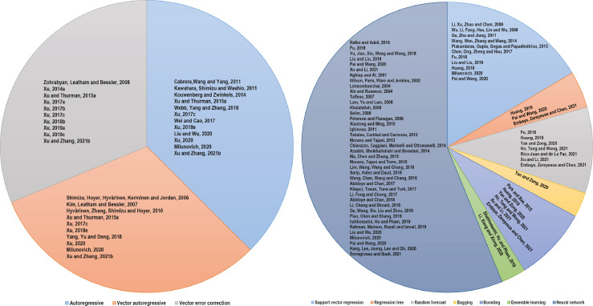
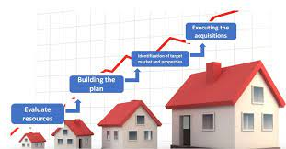

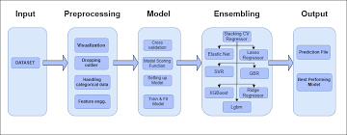

PROGRAM:-
importpandasaspd
importnumpyasnp
importseabornassns
importmatplotlib.pyplotasplt
In [2]:
df=pd.read_csv("/kaggle/input/usa-housing/USA_Housing.csv")
veri=df.copy()
veri.head()
Out[2]:

 | Avg. Area Income | Avg. Area House Age | Avg. Area Number of Rooms | Avg. Area Number of Bedrooms | Area Population | Price | Address
0 | 79545.458574 | 5.682861 | 7.009188 | 4.09 | 23086.800503 | 1.059034e+06 | 208 Michael Ferry Apt. 674\nLaurabury, NE 3701...
1 | 79248.642455 | 6.002900 | 6.730821 | 3.09 | 40173.072174 | 1.505891e+06 | 188 Johnson Views Suite 079\nLake Kathleen, CA...
2 | 61287.067179 | 5.865890 | 8.512727 | 5.13 | 36882.159400 | 1.058988e+06 | 9127 Elizabeth Stravenue\nDanieltown, WI 06482...
3 | 63345.240046 | 7.188236 | 5.586729 | 3.26 | 34310.242831 | 1.260617e+06 | USS Barnett\nFPO AP 44820
4 | 59982.197226 | 5.040555 | 7.839388 | 4.23 | 26354.109472 | 6.309435e+05 | USNS Raymond\nFPO AE 09386
In [3]:
veri.info()
<class 'pandas.core.frame.DataFrame'>
RangeIndex: 5000 entries, 0 to 4999
Data columns (total 7 columns):
# Column Non-Null Count Dtype
--- ------ -------------- -----
0 Avg. Area Income 5000 non-null float64
1 Avg. Area House Age 5000 non-null float64
2 Avg. Area Number of Rooms 5000 non-null float64
3 Avg. Area Number of Bedrooms 5000 non-null float64
4 Area Population 5000 non-null float64
5 Price 5000 non-null float64
6 Address 5000 non-null object
dtypes: float64(6), object(1)
memory usage: 273.6+ KB
In [4]:
veri=veri.drop(columns="Address",axis=1)
In [5]:
df.describe().T
Out[5]:
 | count | mean | std | min | 25% | 50% | 75% | max
Avg. Area Income | 5000.0 | 6.858311e+04 | 10657.991214 | 17796.631190 | 61480.562388 | 6.880429e+04 | 7.578334e+04 | 1.077017e+05
Avg. Area House Age | 5000.0 | 5.977222e+00 | 0.991456 | 2.644304 | 5.322283 | 5.970429e+00 | 6.650808e+00 | 9.519088e+00
Avg. Area Number of Rooms | 5000.0 | 6.987792e+00 | 1.005833 | 3.236194 | 6.299250 | 7.002902e+00 | 7.665871e+00 | 1.075959e+01
Avg. Area Number of Bedrooms | 5000.0 | 3.981330e+00 | 1.234137 | 2.000000 | 3.140000 | 4.050000e+00 | 4.490000e+00 | 6.500000e+00
Area Population | 5000.0 | 3.616352e+04 | 9925.650114 | 172.610686 | 29403.928702 | 3.619941e+04 | 4.286129e+04 | 6.962171e+04
Price | 5000.0 | 1.232073e+06 | 353117.626581 | 15938.657923 | 997577.135049 | 1.232669e+06 | 1.471210e+06 | 2.469066e+06
In [6]:
sns.pairplot(veri)
/opt/conda/lib/python3.10/site-packages/seaborn/axisgrid.py:118: UserWarning: The figure layout has changed to tight
self._figure.tight_layout(*args, **kwargs)
Out[6]:
<seaborn.axisgrid.PairGrid at 0x7819c8fe0d90>

In [7]:
sns.heatmap(veri.corr(),annot=True)
Out[7]:
<Axes: >

In [8]:
importstatsmodels.apiassm
fromstatsmodels.stats.outliers_influenceimportvariance_inflation_factor

y =veri["Price"]
X=veri.drop(columns="Price",axis=1)

cons =sm.add_constant(X)
vif=pd.DataFrame()
vif["variables"]=X.columns
vif["vif"]=[variance_inflation_factor(cons,i+1) foriinrange(X.shape[1])]
vif
Out[8]:
 | variables | vif
0 | Avg. Area Income | 1.001159
1 | Avg. Area House Age | 1.000577
2 | Avg. Area Number of Rooms | 1.273535
3 | Avg. Area Number of Bedrooms | 1.274413
4 | Area Population | 1.001266
In [9]:
fromsklearn.model_selectionimporttrain_test_split,cross_val_score

X_train, X_test, y_train, y_test=train_test_split(X, y,
test_size=0.2,
random_state=42)
In [10]:
fromsklearn.preprocessingimportStandardScaler

ss =StandardScaler()

X_train=ss.fit_transform(X_train)
X_test=ss.transform(X_test)
In [11]:
importsklearn.metricsasmt

defcross_val(model):
vali=cross_val_score(model,X,y,cv=10)
returnvali.mean()
defsuccess(true_,pred):
rmse=mt.mean_absolute_error(true_,pred)
r2=mt.r2_score(true_,pred)
return[rmse,r2]
In [12]:
fromsklearn.linear_modelimportLinearRegression,Ridge,Lasso,ElasticNet
li_model=LinearRegression()
li_model.fit(X_train,y_train)
li_pred=li_model.predict(X_test)

ridge_model=Ridge(alpha=0.1)
ridge_model.fit(X_train,y_train)
ridge_pred=ridge_model.predict(X_test)

lasso_model=Lasso(alpha=0.1)
lasso_model.fit(X_train,y_train)
lasso_pred=lasso_model.predict(X_test)

elas_model=ElasticNet(alpha=0.1)
elas_model.fit(X_train,y_train)
elas_pred=elas_model.predict(X_test)
In [13]:
result=[["Linear model",success(y_test,li_pred)[0],success(y_test,li_pred)[1],cross_val(li_model)],
["Ridge model",success(y_test,ridge_pred)[0],success(y_test,ridge_pred)[1],cross_val(ridge_model)],
["Lasso model",success(y_test,lasso_pred)[0],success(y_test,lasso_pred)[1],cross_val(lasso_model)],
["ElasticNet model",success(y_test,elas_pred)[0],success(y_test,elas_pred)[1],cross_val(elas_model)]
]
pd.options.display.float_format="{:.4f}".format
result=pd.DataFrame(result,columns=["Model","RMSE","R2","Verification"])
result
Out[13]:

 | Model | RMSE | R2 | Verification
0 | Linear model | 80879.0972 | 0.9180 | 0.9174
1 | Ridge model | 80878.9638 | 0.9180 | 0.9174
2 | Lasso model | 80879.0910 | 0.9180 | 0.9174
3 | ElasticNet model | 81617.9048 | 0.9157 | 0.9165

OUTPUT :
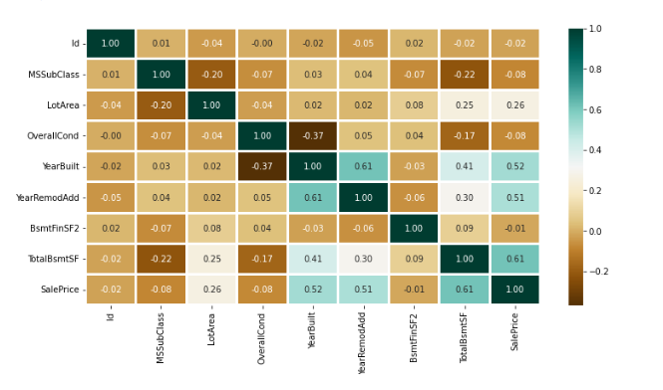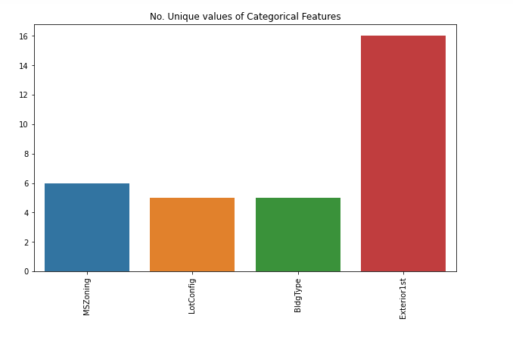
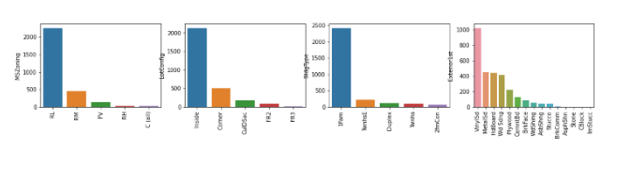
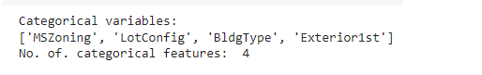
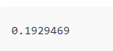

Conclusion:-
Predicting house prices using machine learning has proven to be a powerful tool in the real estate industry. Through this analysis, we have observed that various factors such as location, square footage, number of bedrooms and bathrooms, and external amenities play crucial roles in determining a property's value. Machine learning models, especially regression techniques like linear regression, decision trees, and ensemble methods like random forests, have shown promising results in accurately predicting house prices.
Additionally, feature engineering and data preprocessing are essential steps in enhancing the performance of these models. Techniques like normalization, one-hot encoding, and handling missing values have been instrumental in creating robust and accurate models.
It is important to note that while machine learning models can provide accurate predictions, they are not without limitations. Factors such as sudden market shifts, economic conditions, and unforeseen events can significantly impact real estate prices, making predictions subject to change.
In conclusion, leveraging machine learning for predicting house prices offers significant benefits for both buyers and sellers in making informed decisions. However, it is crucial to continuously update and refine models to adapt to evolving market conditions. Additionally, combining the power of data-driven insights with human expertise can lead to even more accurate and reliable predictions in the dynamic real estate landscape.

